
Micro Credit Project

Submitted by:
Shashwat Shukla

ACKNOWLEDGMENT
I got this project from Flip Robo, they provide all the documentation related to the dataset. I did research on google and different internet blog, which help me to do work on this project.

INTRODUCTION

- Business Problem Framing
Micro credit project is basically based to the credit amount to the user of mobile network service providers. This micro credit solution will help to those customers whom are not able to get mobile recharge at emergency or in any other odd situation, in this situation the mobile network service provide will give mobile recharge to the customer on credit.
- Conceptual Background of the Domain Problem
The concept behind this project is to giving credit balance to their customer on their previous balance history.
- Review of Literature
Micro credit project is based on the loan process the only difference is the amount is very small. I got this project from Flip Robo, they also share the documentation regarding the project documentation and dataset document. I also did google to know the actual impact of this process to the public.
- Motivation for the Problem Undertaken
First, I got big dataset as this and I was also curious to know what is the basic details and qualifying step they need to provide the credit balance. I think these are two factor is the motivation to work with this dataset.

Analytical Problem Framing
- Mathematical/ Analytical Modelling of the Problem
The dataset has 37 columns and 209593 row and most of the columns had integer and float values except Pdate and Pcircle. I found that some columns have no contribution to the target column, I dropped these columns which is Pdate, Unnamed 0, msisdn and Pcircle.
- Data Sources and their formats
The dataset is given by mobile network provider to the flip Robo and Flip Robo shared this dataset to us. This dataset is confidential as the company want to predict that whom they give the micro credit loan or whom not. So, the company want this process should perform automatically to give credit loan to the customer.
- Data Pre-processing Done
What were the steps followed for the cleaning of the data? What were the assumptions done and what were the next actions steps over that? The clean data is the primary to build successful model. The cleaning data process is hold 60-70% weightage in the model building process. First I checked the size of the dataset then checked the null values
- Data Inputs- Logic- Output Relationships
I have the dataset which has 35 columns, some columns have integer and some has float datatype. Some columns have categorical values and some columns have continuous values and I have to predict the result which is categorical values.
- State the set of assumptions (if any) related to the problem under consideration
Approx. all the columns have skewness but I did not deal with skewness because I have assumptions that these are original values and the skewness will be acceptable.
- Hardware and Software Requirements and Tools Used
I am using Dell industrial category laptop with below configuration –
1-Processor- i5
2- Ram -4 GB
3- Windows – Windows 10
But I don’t think this configuration is enough to work on that much big dataset because it will take lots of time to learn and give result. So, I think I have to use more powerful configured system.

Model/s Development and Evaluation

Identification of possible problem-solving approaches (methods)
I performed various type of EDA in scatter plot I found that those customers who has good mobile recharge history will get the micro credit loan. Some columns also look like have same values for all the customer like pcircle and pdate these column dose not has any relation with target.
Testing of Identified Approaches (Algorithms)
I Choose 5 model type to predict the either the customer will get micro credit loan or not. These models mentioned below -
Logistic Regression
RandomForestClassifier
GaussianNB
KNeighborsClassifier
GradientBoostingClassifier

Key Metrics for success in solving problem under consideration
To make model good as the aspect to accuracy we have to perform or compare with all the matrix. I used cross validation, confusion matrix and accuracy report for all the models.

Visualizations

Scatter Plot
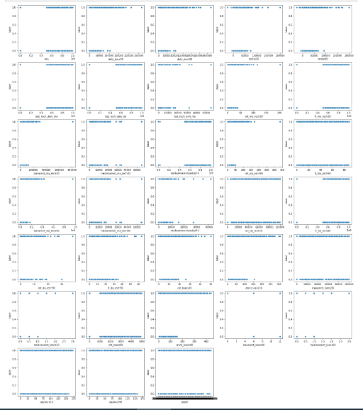

Scatter plot I found that those customers who has good mobile recharge history will get the micro credit loan. Some columns also look like have same values for all the customer like pcircle and pdate these column dose not has any relation with target

Heat Map
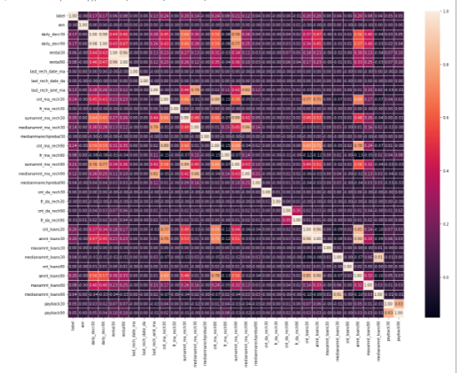

I plot the Heatmap to find the multicollinearity, lots of feature has multicollinearity and those features which is separating in 30days and 90 days category. So, I removed some feature who has more than 90% multicollinearity.

Lots of columns has Multicolinearity and this will mislead the accuracy of the model. So, I will drop the column which has multicolinearity more than 80% and putting the same impact to the targte whihc is Label.

Payback30 and Payback90 has Multicolinearity 83% and contribute on the target same.
medianamnt_loans30 and medianamnt_loans90 has Multicolinearity 91% and contribute on the target same.
amnt_loans30 and amnt_loans90 has Multicolinearity 90% and contribute on the target same.
amnt_loans90 and cnt_loans30 has Multicolinearity 85% and contribute on the target same.
amnt_loans30 and cnt_loans30 has Multicolinearity 96% and contribute on the target same.
cnt_ma_rech30 and cnt_ma_rech90 has Multicolinearity 89% but contribute on the target same.
daily_decr30 and daily_decr90 has Multicolinearity 96% and contribute on the target same.

There are some more columns which has Multicolinearity but contribute with different percentage on target which is label. So, I will keep these column for model building.
Density Plot
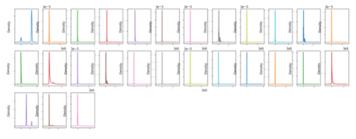
I plot the density plot to find the distribution of values and I found that almost of the feature has skewness but I did not work on that skewness.

Box Plot
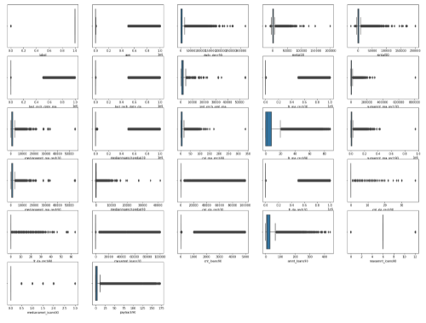
I plot box plot to check the outliers and all columns has lots of outliers. So, I tried to remove these outliers with the help z-score but as the outliers are very much so I just removed some outliers and I loss the approx. 8.2%. I cannot remove all the outliers because the data is valuable.
Interpretation of the Results
I performed 5 model prediction Accuracy score, those score are mentioned below -

Accuracy score and cross validation score for LogisticRegression model 76.34 and cross validation score is 75.27
Accuracy scores cross validation score for RandomForestClassifier model 97.94 and cross validation score is 97.94
Accuracy scores cross validation score for GaussianNB model 69.81968534495626 and cross validation score is 69.55
Accuracy scores cross validation score for KNeighborsClassifier model 87.28 and cross validation score is 87.48
Accuracy scores cross validation score for GradientBoostingClassifier model 80.14 and cross validation score is 80.45

From the above, I conclude that I will go forward with RandomForestClassifier because the accuracy is good comparison to other model and has very low difference in Cross validation score. As the RandomForestClassifier is performing pretty good. I do not need to perform any hyperparameter tunning.
CONCLUSION
- Key Findings and Conclusions of the Study
I all the model building process I found that the criteria of getting the micro credit balance is very easy and probably every user will get this micro credit loan easily. I also found that service provider is keen to offer micro credit loan to the customers.
- Learning Outcomes of the Study in respect of Data Science
As the dataset is big, I found that every step from fetching dataset to cleaning the dataset is need more attention so, that nothing left to observe. The data set has no null values this is best part of the dataset and no column has character values which is another good part of the dataset.
- Limitations of this work and Scope for Future Work
I do not think that there was any limitation for this project and the project has good future, as this dataset working on the credit balance of the mobile user which has good exposure in the future.

